**Biomass pyrolysis**

Yield of various products as a function of the composition of biomass.

The following simulations were done at the Temperature of 6000 C. (isothermal case)

In each of the cases the first image represents the ”side view ” of the plot and the second image represents the “top view”.

The colour represents the height such that red means higher yield and blue means lower yield.

All outputs are in kilograms.

Reactant mass is 1 kilogram.

The concentrations of Lignin-C, Lignin-H and Lignin-O are assumed equal.

**Note:** These plots do not appear smooth since the yields were calculated only for about 50 points. (The running time is very large therefore more accurate graphs will take time to simulate). But since the graphs will always be planes (since we assume the three components react independently) we can still get a rough idea of how the continuous graph would look like.

**Hydrogen:**

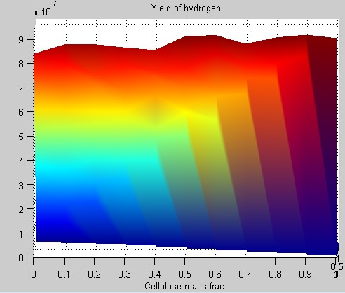

“side view”

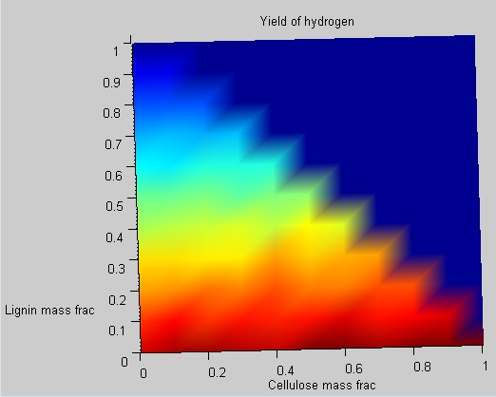

“top view”

Our domain is only the bottom left ‘right angled triangle’ (since the top right has HCE mass fraction negative)

**Char:**

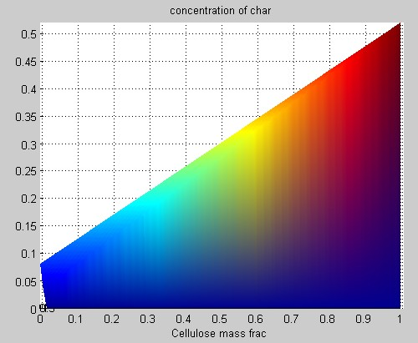

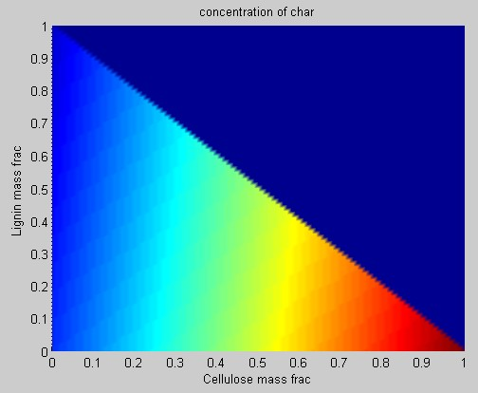

**Methane:**

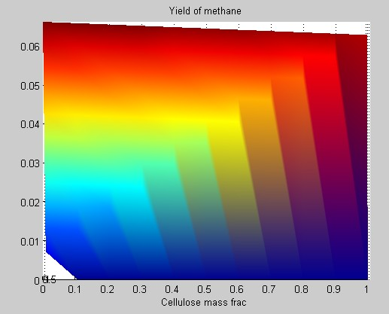

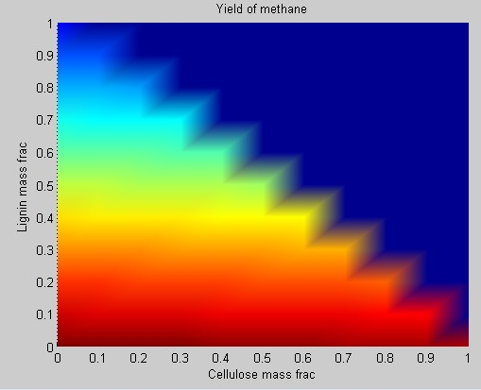

**Carbon Monoxide:**

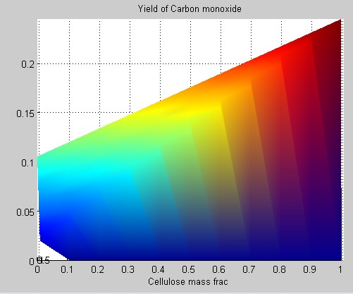

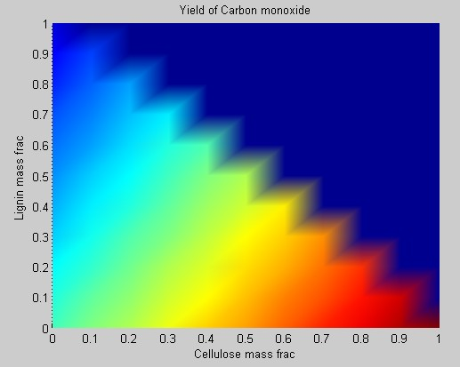

**Carbon Dioxide:**

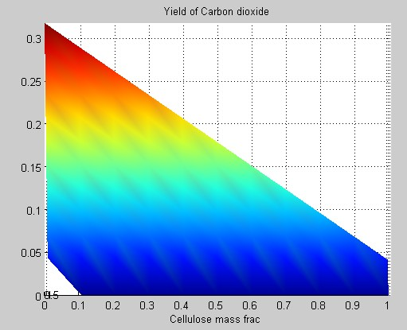

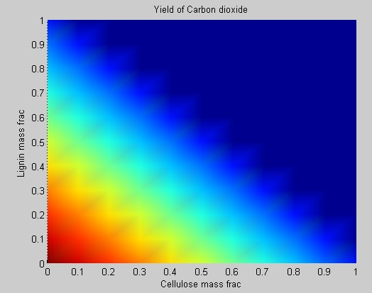

**Water:**

